Name:



Total marks /50

**Year 10- Global Cycles Assignment- 15%**

**TASK:**

Through the creation of a poster in test conditions you are to describe what happens in one of the three global cycles you have learnt about in class. You can choose which cycle you wish to describe out of:

1. The Carbon Cycle
2. The Nitrogen Cycle
3. The Water Cycle

**TIPS AND HINTS:**

* Draw diagrams to explain the cycle.
* Ensure you include arrows to show the direction of each stage of the cycle.
* Annotate (write notes) on the poster at each stage of the cycle to explain in detail what is occurring.
* Define any key terms relevant to the cycle.

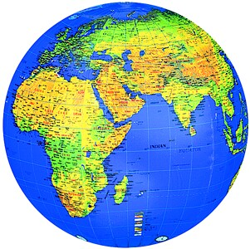

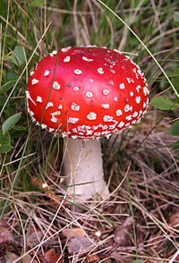

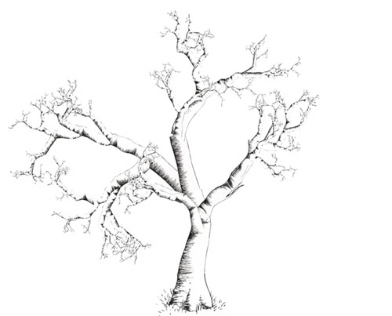

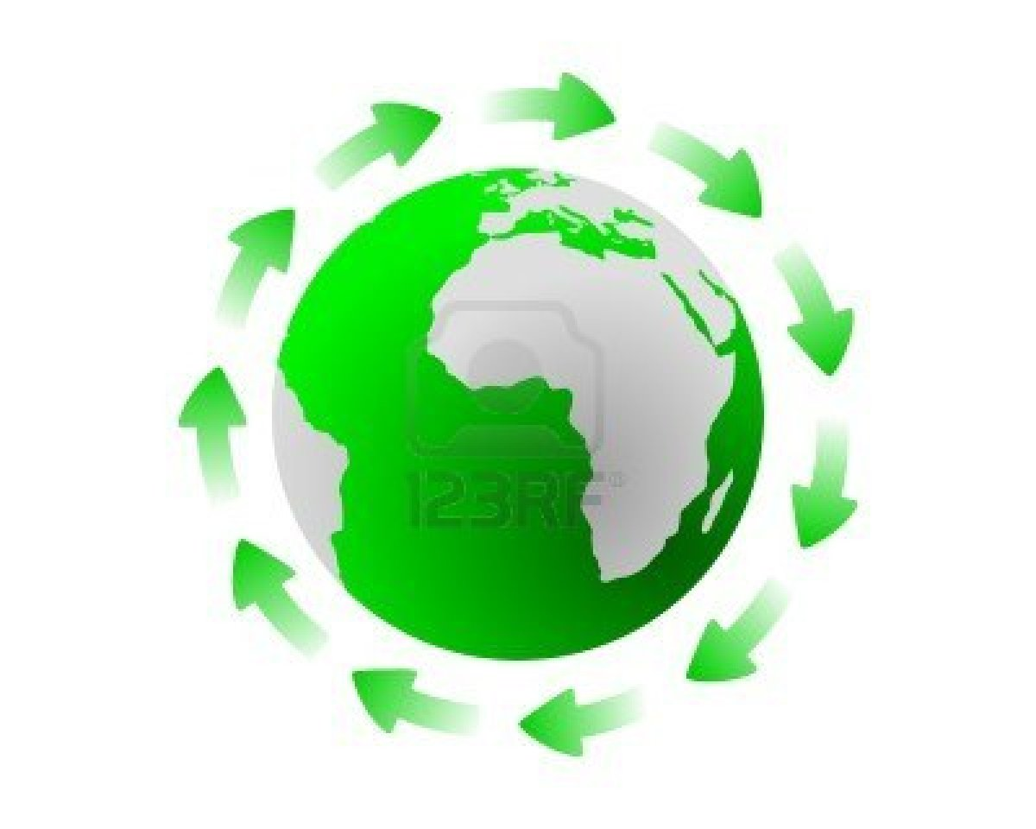



**Some key terms- (NOTE: These are key terms for all the cycles so might not necessarily be needed for yours).**

Carbon, nitrogen, water, transpiration, bacteria, respiration, nitrification, percolation, legume, condensation, ammonification, combustion.